MODERN DATABASE SYSTEMS LAB 5

RETAIL SALES ANALYTICS PART1

NAME: PAVITHIRAN.V ROLL NO: 235229122

Question 1:

SELECT * FROM sales_data WHERE ROWNUM <= 5;

SELECT * FROM stores_data WHERE ROWNUM <= 5;

SELECT * FROM features_data WHERE ROWNUM <= 5;

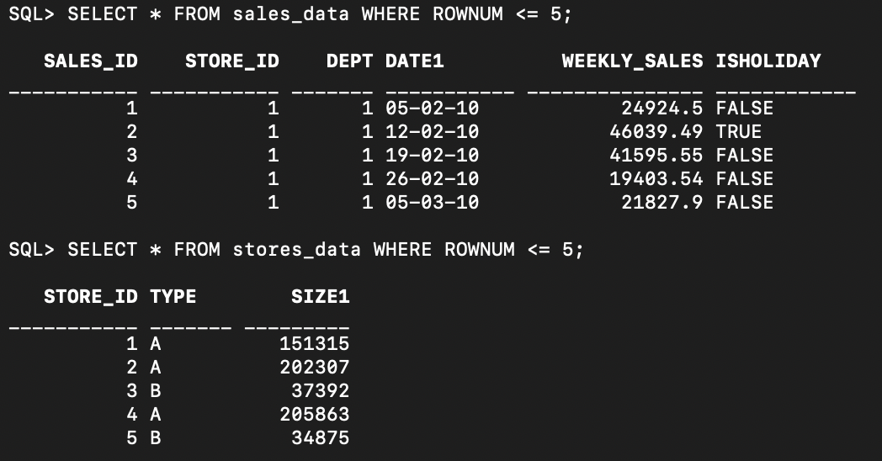

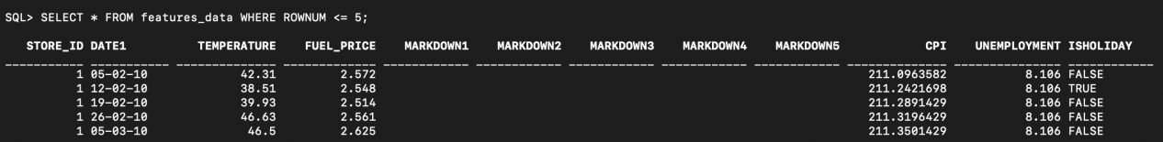

Question 2:

ALTER TABLE sales_data

ADD CONSTRAINT pk_sales_id PRIMARY KEY (SALES_ID);

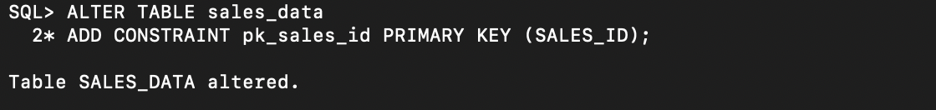

ALTER TABLE stores_data

ADD CONSTRAINT pk_store_id PRIMARY KEY (STORE_ID);

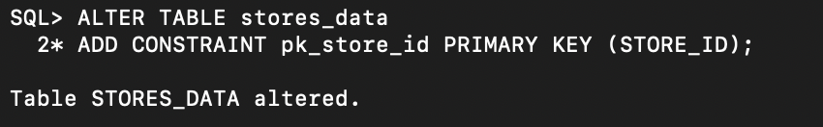

ALTER TABLE features_data

ADD CONSTRAINT fk_store_id FOREIGN KEY (STORE_ID)

REFERENCES stores_data(STORE_ID);

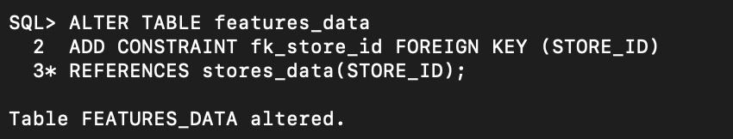

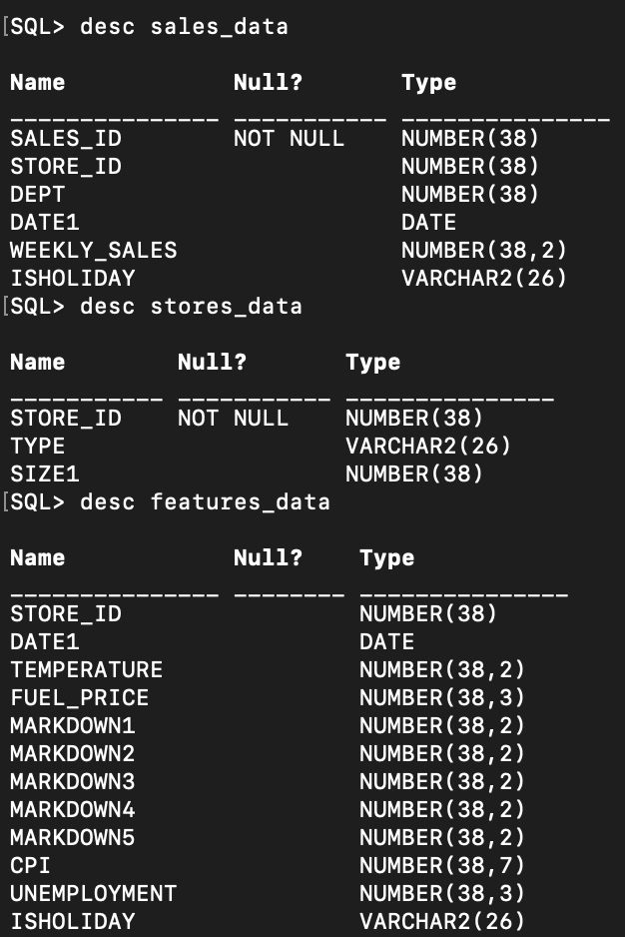

Question 3

SELECT *

FROM sales_data

WHERE ISHOLIDAY = 'TRUE'

ORDER BY WEEKLY_SALES DESC

FETCH FIRST 3 ROWS ONLY;

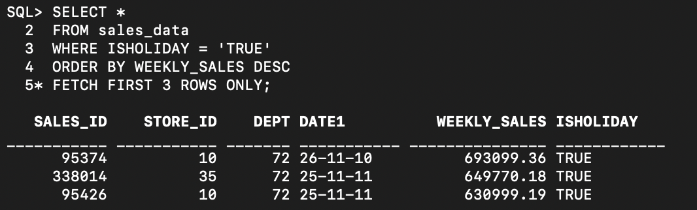

SELECT *

FROM sales_data

WHERE STORE_ID = 1

ORDER BY DATE1 ASC

FETCH FIRST 4 ROWS ONLY;

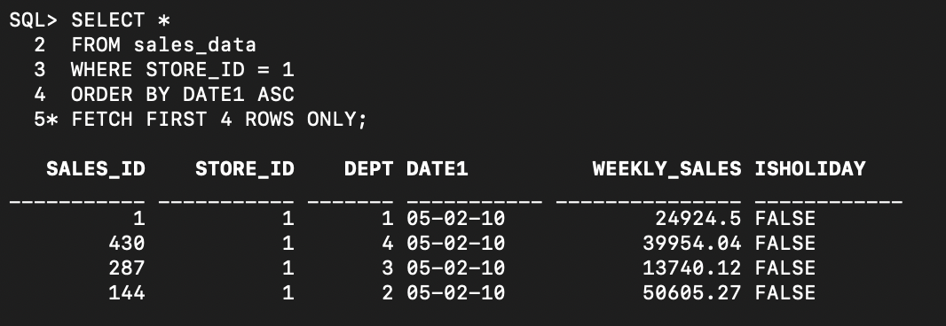

SELECT *

FROM stores_data

WHERE TYPE = 'A'

ORDER BY SIZE1 DESC

FETCH FIRST 2 ROWS ONLY;

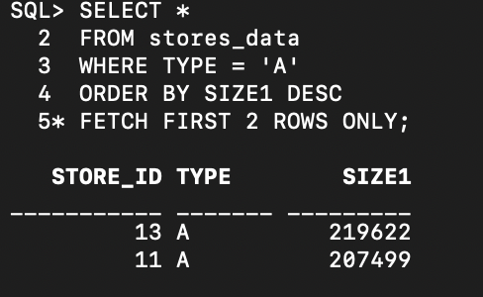

SELECT *

FROM stores_data

WHERE SIZE1 > 3000

ORDER BY TYPE ASC, STORE_ID ASC

FETCH FIRST 5 ROWS ONLY;

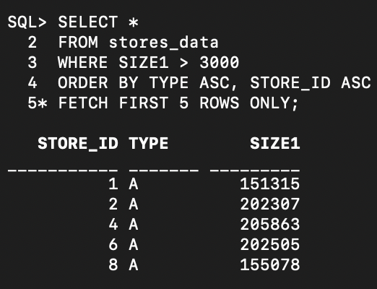

SELECT *

FROM features_data

WHERE TEMPERATURE > 80

ORDER BY STORE_ID

FETCH FIRST 3 ROWS ONLY;

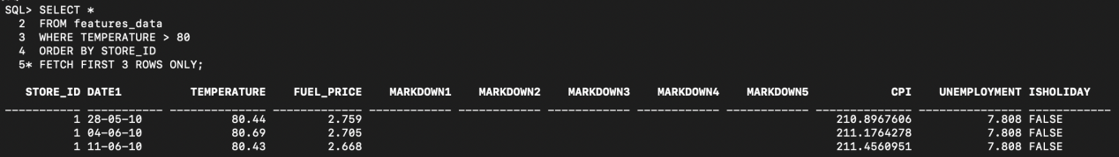

SELECT store_id ,Date1, temperature

FROM features_data

WHERE DATE1 = '12-02-2010'

ORDER BY UNEMPLOYMENT DESC

FETCH FIRST 4 ROWS ONLY;

